dataflywheelwebinar11750179325636.pdf
Refine AI Agents through Continuous Model Distillation with Data Flywheels Blueprint by NVIDIA | NVIDIA NIM

Build Efficient AI Agents Through Model Distillation With the NVIDIA Data Flywheel Blueprint | NVIDIA Technical Blog
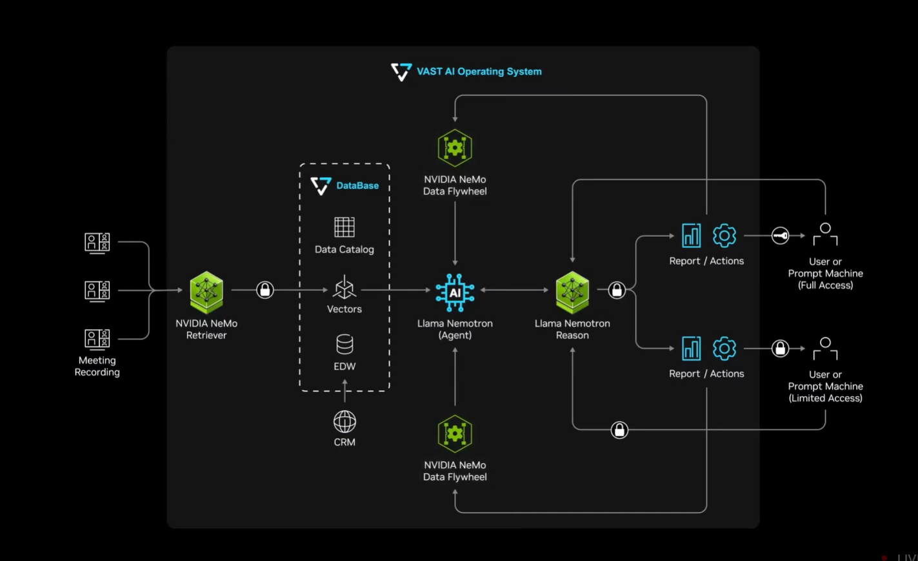

Beyond the Algorithm with NVIDIA: Distill Cost-efficient Models with NVIDIA Data Flywheel Blueprint
Optimize AI Agents with Continuous Model Distillation and Evaluation Using a Data Flywheel - YouTube
NVIDIA NeMo Microservices - NVIDIA Docs
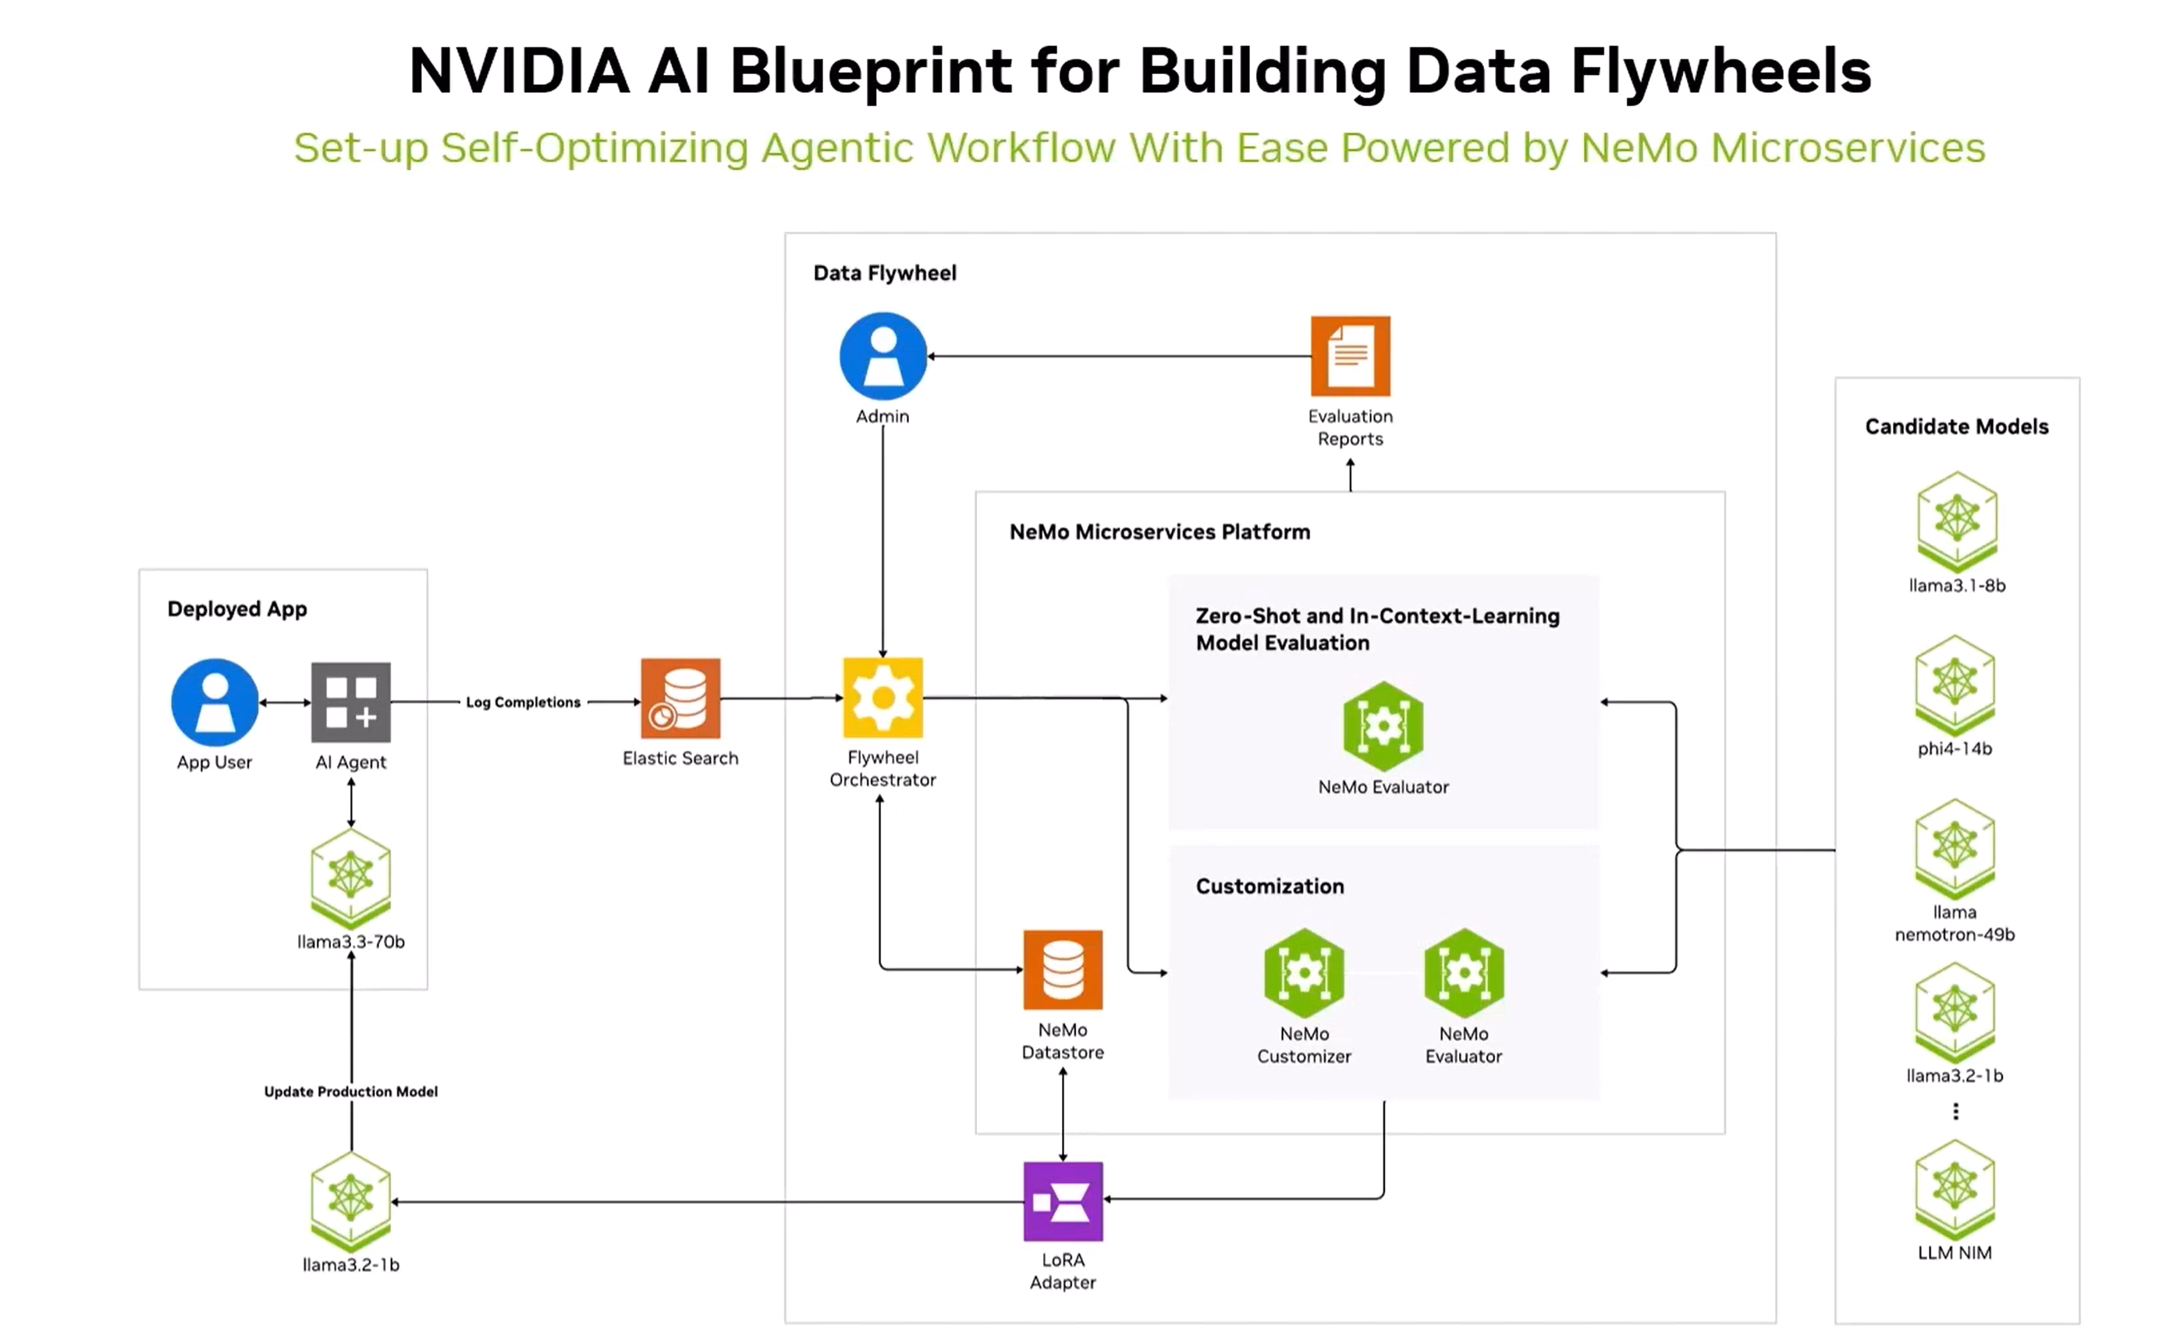

Deep Learning Institute (DLI) Training and Certification | NVIDIA

Will I get a certificate for attending?

For certifications, please check out: https://www.nvidia.com/en-us/training/

How can I use this knowledge when I am not technically prepared, I just want to make my business more efficient, where do I start, who should I recruit/outsource (skills) assuming I myslef won't acquire those skills?

one of the first few things we advice - is to start thinking about centralizing log/feedback/agent interaction data collection. Data is the value driver - as you think about business problems to solve and get right folks on board.

When can we get the blackwell hardware to run this at a reasonable price? I have a "Reservation Confirmation" for dgx spark from March 18th. No updates.

Love the excitement. DGX spark production is in full swing. said to be available later this year. Appreciate the patience. its going to be worth the wait

Do you have a solution for RL? If I don't want to finetune by model using SFT, etc. but want to RL for a very verifiable workflow, can Nemo microservice help with that? Also, will I need to have my real environment for the RL or you have a digital twin solution to recreate my workflow for RL?

Absolutely. do check out our latest NeMo RL OSS library- https://github.com/NVIDIA-NeMo/RL

Aside from complex documents, what about structured data retrieval and reranking against unstructured data?

Please checkout our Retriever models as hosted APIs https://build.nvidia.com/models?q=retriever

could you walk through use cases where data flywheels are used to build an AI support bot from scratch?

Please checkout our Datafly wheel Blueprint https://build.nvidia.com/nvidia/build-an-enterprise-data-flywheel

Are Nvidia models publicly/open source available for testing/building

Yes Nemotron on HuggingFace https://huggingface.co/docs/transformers/en/model_doc/nemotron and as hosted APIs https://build.nvidia.com/models

How can we verify the accuracy and reliability of NeMo Evaluator's assessment of models?

One of the way you could do is pick academic benchmarks and contrast evaluations across market alternatives

